1. 项目结构：
2. 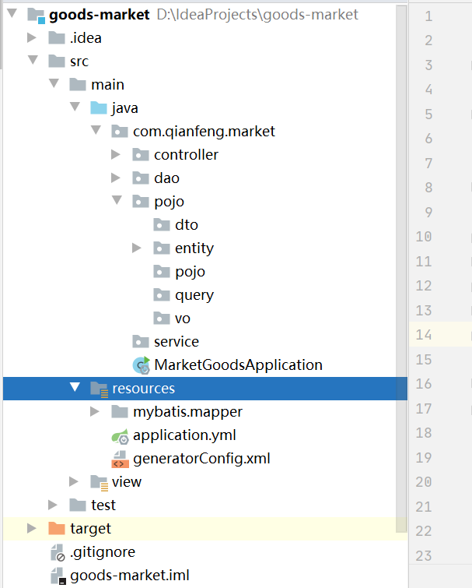
3. pom.xml

|  |
| --- |
| *<?*xml version="1.0" encoding="UTF-8"*?>* <project xmlns="http://maven.apache.org/POM/4.0.0" xmlns:xsi="http://www.w3.org/2001/XMLSchema-instance"  xsi:schemaLocation="http://maven.apache.org/POM/4.0.0 https://maven.apache.org/xsd/maven-4.0.0.xsd">  <modelVersion>4.0.0</modelVersion>  <parent>  <groupId>org.springframework.boot</groupId>  <artifactId>spring-boot-starter-parent</artifactId>  <version>2.3.4.RELEASE</version> *<!-- <relativePath/> &lt;!&ndash; lookup parent from repository &ndash;&gt;-->* </parent>  <groupId>com.qianfeng</groupId>  <artifactId>market-goods</artifactId>  <version>0.0.1-SNAPSHOT</version>  <name>market-goods</name>  <description>这是一个商场项目</description>   <properties>  <java.version>1.8</java.version>  </properties>   <dependencies>  <dependency>  <groupId>org.springframework.boot</groupId>  <artifactId>spring-boot-starter-web</artifactId>  </dependency>  <dependency>  <groupId>org.springframework.boot</groupId>  <artifactId>spring-boot-starter-thymeleaf</artifactId>  </dependency>  <dependency>  <groupId>org.mybatis.generator</groupId>  <artifactId>mybatis-generator-core</artifactId>  <version>1.3.2</version>  </dependency>    *<!-- <dependency>  <groupId>org.springframework.boot</groupId>  <artifactId>spring-boot-starter-test</artifactId>  <scope>test</scope>  <exclusions>  <exclusion>  <groupId>org.junit.vintage</groupId>  <artifactId>junit-vintage-engine</artifactId>  </exclusion>  </exclusions>  </dependency>-->* </dependencies>   <build>  <pluginManagement>  <plugins>  <plugin>  <groupId>org.springframework.boot</groupId>  <artifactId>spring-boot-maven-plugin</artifactId>  </plugin>   </plugins>  </pluginManagement>   <plugins>  <plugin>  <groupId>org.mybatis.generator</groupId>  <configuration>  <configurationFile>src/main/resources/generatorConfig.xml</configurationFile>  <verbose>true</verbose>  <overwrite>true</overwrite>  </configuration>    <artifactId>mybatis-generator-maven-plugin</artifactId>  <version>1.3.2</version>   </plugin>  </plugins>  </build>  </project> |

1. 安装idea-mybatis-generator插件
2. 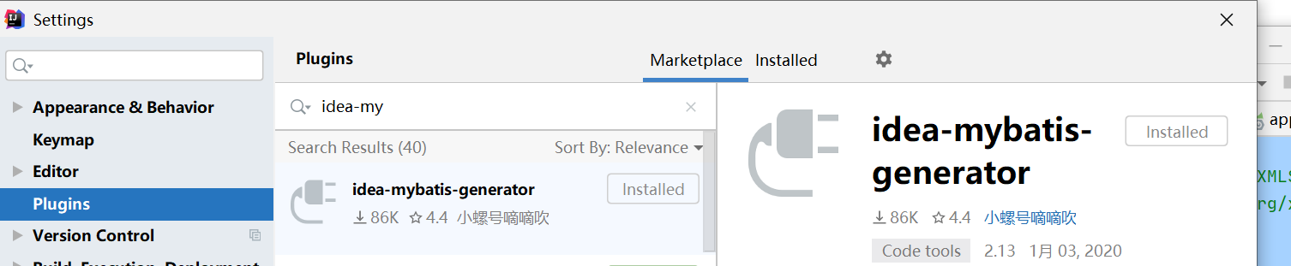
3. 配置运行命令
4. 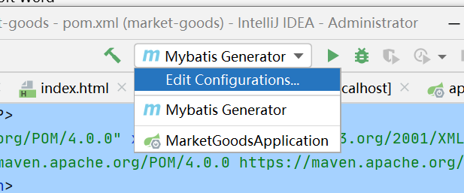

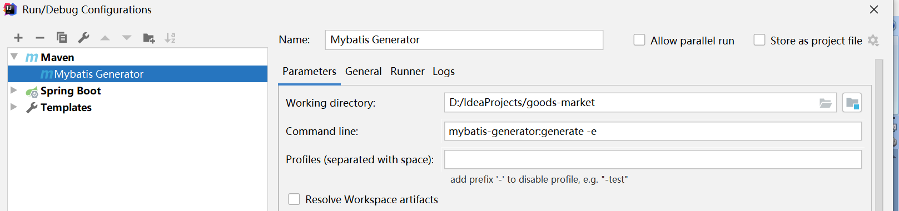

对应的数据库表

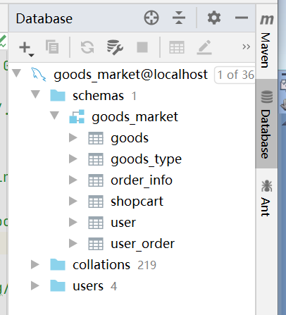

添加generatorConfig.xml，内容如下，根据实际目录结构，写错了不会生成实体类和mapper以及mapper.xml

|  |
| --- |
| *<?*xml version="1.0" encoding="UTF-8" *?>* <!DOCTYPE generatorConfiguration PUBLIC "-//mybatis.org//DTD MyBatis Generator Configuration 1.0//EN" "http://mybatis.org/dtd/mybatis-generator-config_1_0.dtd" *>* <generatorConfiguration>  <classPathEntry location="C:/Users/Administrator.WIN-5OKFMRREPRH/.m2/repository/mysql/mysql-connector-java/5.1.49/mysql-connector-java-5.1.49.jar"/>  <context id="productRelease">  <property name="mergeable" value="false" />  <plugin type="org.mybatis.generator.plugins.SerializablePlugin" />  <jdbcConnection driverClass="com.mysql.jdbc.Driver"  connectionURL="jdbc:mysql://localhost:3306/goods_market"  userId="root" password="root" />  <javaModelGenerator targetPackage="entity"  targetProject="src/main/java/com/qianfeng/market/pojo" />  <sqlMapGenerator targetPackage="mapper"  targetProject="src/main/resources/mybatis" />   <javaClientGenerator targetPackage="dao"  targetProject="src/main/java/com/qianfeng/market/" type="XMLMAPPER" />  <table tableName="goods" />  <table tableName="goods_type" />  <table tableName="order_info" />  <table tableName="shopcart" />  <table tableName="user" />  <table tableName="user_order" />  </context> </generatorConfiguration> |

配置好后，点击运行按钮就可以生成对应的文件

